1

Internship Report

Name

degree

Internship Supervisor: Morgan Schrauben
Internship Mentor:

Internship Director:

Organization

Table of Contents

Acknowledgment 2

Internship Objectives………………………………………….………………………………………………………………………………….2

Introduction 2

Description of work 2

Discussion 5

References 6
2

Acknowledgment:

I would like to express my gratitude to Dr. XXX for his support throughout my master’s course work. I will always be grateful for his mentorship, advice and support throughout this journey. I would also like to thank Erin Crummel for guiding me during my Internship and for her continuous academic and personal advice, and I am equally thankful for site, university, xx faculty for their support and guidance in building my Internship.

Internship objectives

- To gain more knowledge about the technical aspects of health Information technology

- To explore my area of interest in Health IT.

- To develop programming skills and be able to work independently on projects

- To apply the theoretical knowledge gained through course work in a practical setting.

- To work on my communication skills by participating in discussions

- To develop networking skills and build connections with other professionals.

Introduction:

MiHIN is a public and private nonprofit created for the purpose of coordinating and building the bridges between the healthcare providers throughout the state. From hospitals to pharmacies, MiHIN is creating the technology and resource needed to make sure that the electronic health records of Michigan citizens are available for all that provide care. MiHIN represents a growing network of public and private organizations working to overcome data sharing barriers, reduce costs, and ultimately advance the health of Michigan’s population.

MiHIN offers the internship program in which each intern will be paired with a full-time team member to act as your mentor throughout your Internship and the opportunity to collaborate with your mentor, other team members, and other interns on projects and presentations.

Description of Work:

My position in MiHIN was labeled as an Enterprise production Analyst, and I worked under the Enterprise production operations team. My daily work included applications such as Salesforce, Tableau, Amazon workspaces, Visio, and Excel.
3

Worked on:

1. Admission, Discharge and Transfer Notification Reports

Admission, discharge, transfer (ADT) notifications are widely regarded as a keystone to improving patient care coordination through health information exchange. ADT notifications also help to identify patients who are frequent or high users of the healthcare system. This allows providers to steer those patients toward clinical and non-clinical interventions, reducing overutilization by preventing avoidable emergency department visits and hospital readmissions. I had worked to create the ADT subscriptions of all the health care organizations of Michigan utilizing Tableau. I provided ADT message fallouts for conformance using Tableau and WinSCP.
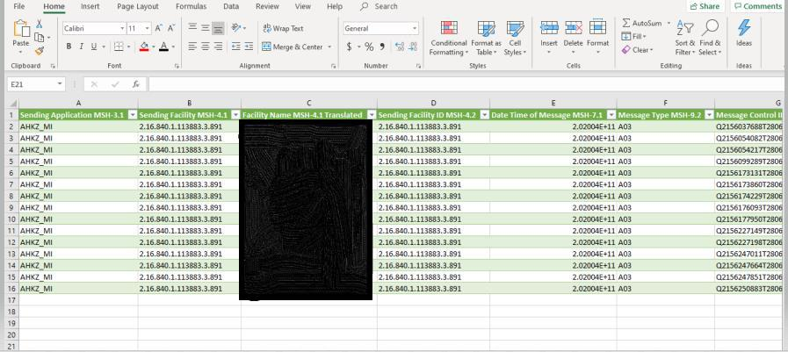

Figure 1: (Overview of Conformance report of ADT messages Analyzed in Excel)

2.Medication Reconciliation Reports

Medication reconciliation is the detailed process of checking the accuracy of a patient’s medications, particularly when those medications have changed. Finding and correcting medication discrepancies helps avoid errors such as omissions, duplications, dosing errors, or negative drug interactions. Most of my work included creating Med Rec subscriptions for all the health care organizations of Michigan and providing message fallouts for conformance.
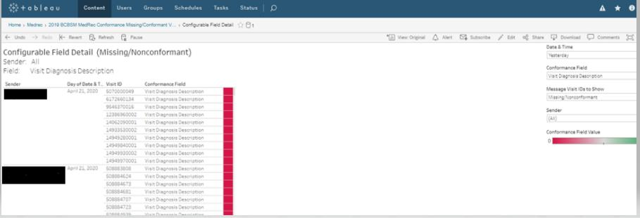

Figure 2: (Overview of Conformance report of Medication Reconciliation Report retrieved from Tableau)

4

- Performed continuous tracking of the tickets assigned in Salesforce to enhance operational excellence for customers and various health organizations of Michigan and New Jersey. Acted on requests from clients and made sure their needs were met before the due date.
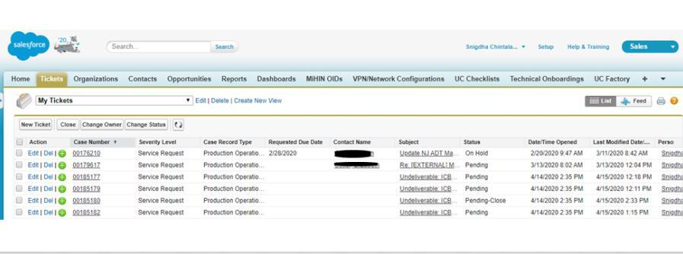

Figure 3: (preview of tracking tickets in Salesforce)

- My work also included creating and managing workflow, data validation, process, and flowed for the end-users utilizing Visio Tool. It also includes processing documentation for internal excellence and process improvement.
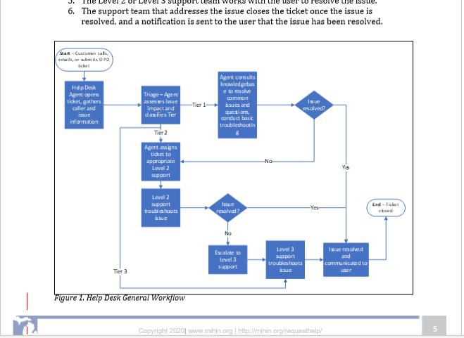

Figure 4: (Snapshot of processing internal documentation visuals utilizing Visio Tool)

5.Biweekly Intern Touch base:

In MiHIN, interns are assigned to groups based on their schedule, and various workshops such as communication, resume writing, presentations were conducted. Through this wonderful opportunity,
5

I had a chance to learn about other interns’ experiences in MiHIN, and all the workshops conducted attributed to professional growth.

6.Weekly Touch base:

Every week I was assigned a touch base meeting with my mentor, which helped me gain the objectives I listed at the beginning of the Internship, I would want to achieve through this experience. These meetings not only helped me achieve the objectives such as improving my communication skills but also in receiving regular feedbacks over my work.

DISCUSSION:

By working In MiHIN, I had this wonderful opportunity to grow up my connections in various other departments such as Onboarding, Rhapsody, Helpdesk, and Human resources. This Internship is a wonderful experience to realize my work style and to improve it to the best level.

It helped me to design my professional work style. This Internship helped me realize the importance of communication and how helpful it is when we are dealing with end-users. Regular appreciations from my mentor and other team members made me feel more responsible towards my work. This experience in MiHIN helped me learn more technologies, opportunities for growth in career and learn more about Health IT.

Objectives achieved:

Through this internship experience, I had the opportunity where I was paired up with a full time position member who was my mentor throughout this experience with who I did participate in many training sessions during initial periods of my Internship which helped me gain more knowledge about technical aspects of Health Care IT.

I did participate in meetings with other teams and attended workshop with interns from other teams .This opportunity to interact with other teams helped me gain exposure over various Health Care IT fields and helped me explore my area of interest in Health IT and build connections with professionals from other fields.

This internship opportunity led me to be more efficient at work, work effectively both independently and together as a team while improving my knowledge in health care IT.

I was also able to participate in weekly team discussions and weekly meetings with my mentor which led me to work more on my communication skills.
6

Difficulties faced:

The difficulties I had met during my Internship was able to adapt to the different work culture; I was experienced in before. Also, managing time was one of the biggest challenges I had faced during this opportunity since I had to move to Lansing for this position but also had to commute to Grand Rapids for classes in the evenings. However, my mentor and supervisor were kind enough to understand and permit working from home for the requested days and whenever required.

Overall Experience:

This whole experience not only helped me improve my resume within Health Care IT, it also helped me achieve a lot of knowledge and practical experience in the field. This program was very beneficial to me by helping me achieve better communication, networking and helped to expand the scope of my career in the IT field.

Impact of Course work:

The course work in Health and clinical informatics helped me in a better understanding of Health care in the United States and the significance of protecting the patient data. The course work, which included Data visualization, Information Management, Data mining, and clinical Informatics, helped in building up a strong foundation and knowledge in this field. This course work helped me in gaining confidence to pursue a career in the Health care IT field, and PSM course work prepared me for the professional content of the internship program.

SUPERVISOR SIGNATURE:

REFERENCES:

1.ADT information retrieved from https://mihin.org/wp-content/uploads/2019/03/MiHIN-UCS-ADT-Notifications-v17-03-04-19.pdf

2.Med Rec information retrieved from https://mihin.org/discharge-medication-reconciliation

